

Python Project – Calculator GUI

Low-Level Design (LLD)

Internship Project

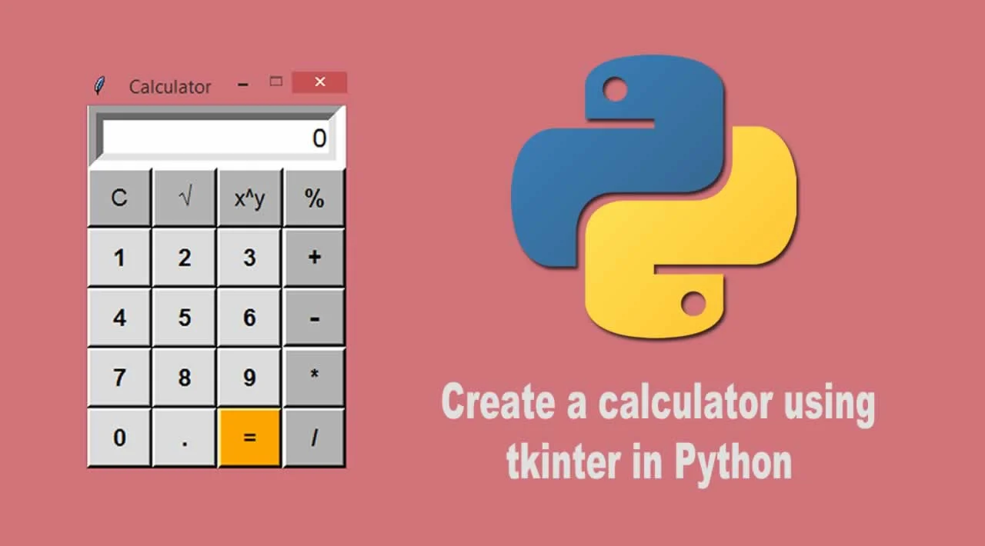

By

Rahul Sharma

Python Project – Calculator GUI

**DOCUMENT VERSION CONTROL**

|  |  |  |  |
| --- | --- | --- | --- |
| Date Issued | Version | Description | Author |
| 20/06/2022 | 1.0 | Introduction to Problem - Statement | Rahul Sharma |
| 22/06/2022 | 1.2 | GUI Working | Rahul Sharma |
| 24/06/2022 | 1.3 | Completion and Deployment | Rahul Sharma |

Contents

# Document Version Control……………………………………………… …..2

# 1. Introduction……………………………………………………………. ……….4

# 1.1 What is a Low-Level Design Document?............................. 4

# 1.2 Scope……………………………………………………………………………… 4

# 1.3 Project Introduction………………………………………………………. 4

# 1. Problem Statement.…………………………………………………… ……5

# 2. Dataset Information……………………………………………………. ….5

# 3. Architecture………………………………………………………… …………6

# 4. 4.1 Architecture Description ………………………………… ……….6

INTRODUCTION

* 1. **What is a Low-Level Design Document?**

The goal of the Low-level design document (LLDD) is to give the internal logic design of the actual program code for the Heart Disease Diagnostic Analysis dashboard. LLDD describes the class diagrams with the methods and relations between classes and program specs. It describes the modules so that the programmer can directly code the program from the document.

* 1. **What is Scope?**

Low-level design (LLD) is a component-level design process that follows a step-by-step refinement process. The process can be used for designing data structures, required software architecture, source code, and ultimately, performance algorithms. Overall, the data organization may be defined during requirement analysis and then refined during data design work.

* 1. **Project Introduction**

The purpose of a calculator is **to do correct calculations and to do so efficiently**. A calculator should relieve the user of the need to do mental operations and of the need to rely on paper, as far as possible.

**2. Problem Statement**

In today’s time, calculators in schools are just as widely used as computers are. Since its invention nearly forty years ago, the electronic calculator has evolved from the machine that could only perform simple four-function operations ( addition, subtraction, multiplication, division) into one that can now also execute highly technical algebraic symbolic manipulations instantly and accurately. Each new generation of calculators builds on the previous one, with heightened speed and more advanced capabilities.

**3. Dataset Information**

A user-friendly GUI Calculator with the help of Python Programming Skill,OOPS, and Tkinter.

**4.Architecture**

**4.1 Architecture Description**

**1. Raw Data Collection**

The Dataset was taken from iNeuron’s Provided Project Description Document.

https://drive.google.com/file/d/1a98FOFMC4kqRbUOpZj7lTkn0UZyEWJvB/view

**2. Data Pre-Processing**

Before building any model, it is crucial to perform data pre-processing to feed the correct data to the model to learn and predict.

**3. Deployment**

